**Calibration Procedure for 600W 12V**

**By wuheng**

**Calibration Procedure Using the 78M6610+PSUEVK**

This section explains step-by-step the calibration procedure using a standard 78M6610+PSU EV board mounted to a 750W server power supply.

Calibration requires two points and includes voltage, current, and X+Y capacitor compensation coefficients.

The power supply has been modified to allow the EV board to be easily connected. The measurement location is typical for this kind of application;

**Figure 7** shows the power-supply input stage (EMI filters) and the EV board.

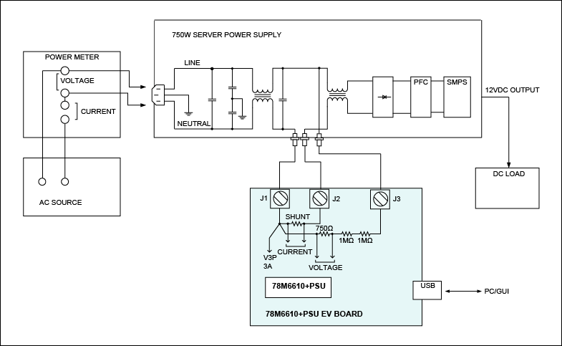  
*Figure 7. Test setup for calibration example.*

In order to perform in-system calibration of the 78M6610+PSU, a stable AC supply source and load on the output of the power supply is needed. The inlet current and voltage also need to be known.

If the AC source cannot provide accurate readings of current and voltage, a power meter is needed.

For this example, the following equipment is used:

* **AC source: Chroma® model 6430**
* **Power meter: Chroma model 66202**
* **DC load: Chroma model 6314, 63106 (DC load mainframe and DC electronic load module)**
* **Computer with the standard GUI that is provided with the 78M6610+PSUEVK**

**Step 1. Current Gain Calibration**

In this step (see **Figure 8**), the current gain is calibrated. The value of the X+Y capacitor compensation coefficient must be set to zero. The power-supply output must be loaded in order to *obtain a power factor approximating unity;*

the power factor is measured through the power meter.

The power-supply input should be set to the lower range of the working voltage (e.g., 100VAC).

By doing so, the effect of the current on the filter capacitors is minimized and thus, a greater accuracy can be obtained. *The value of the current read through the power meter must be entered as a new target current*, and the calibration command must be entered.

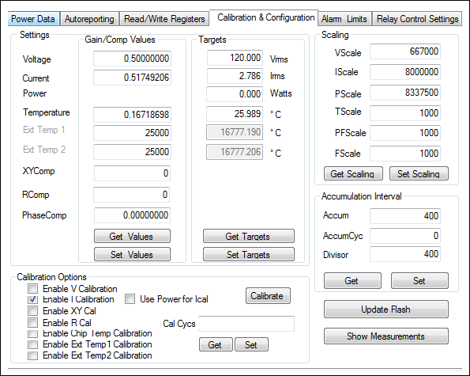  
*Figure 8. Calibrating the current gain in the 78M6610+PSUEVK GUI.*

**Step 2. Voltage Gain Calibration**

The second step (see **Figure 9**) consists of calibrating the voltage gain.

In this step, the output load can be reduced. *The input voltage should be set to the upper range*.

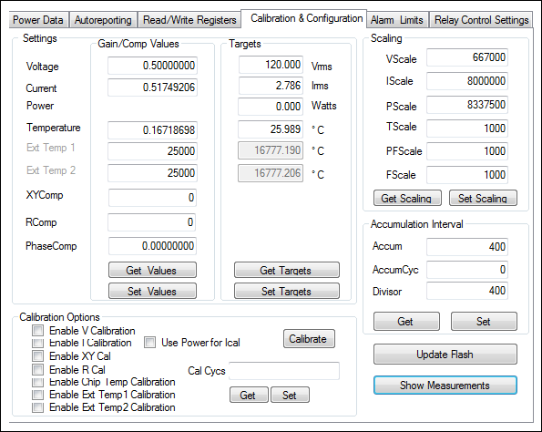  
*Figure 9. Calibrating the voltage gain in the 78M6610+PSUEVK GUI.*

**Step 3. X+Y Capacitor Compensation Coefficient Calibration**

In the third step (see **Figure 10**), the compensation coefficient for the X+Y capacitor is set.

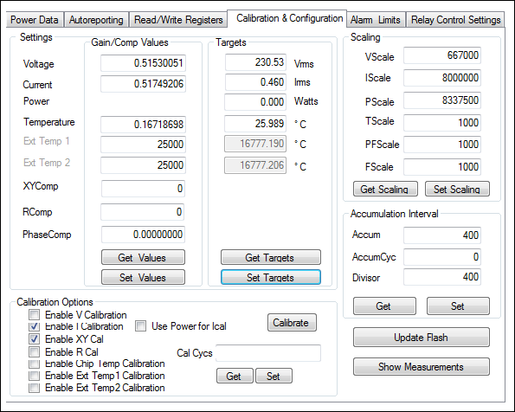  
*Figure 10. Calibrating the X+Y capacitor compensation coefficient in the 78M6610+PSUEVK GUI.*

**Step 4. Storing the Newly Calculated Coefficients in Flash as Defaults**

**Accuracy Results**

The accuracy results following calibration are shown in **Figures 11** and **12**.

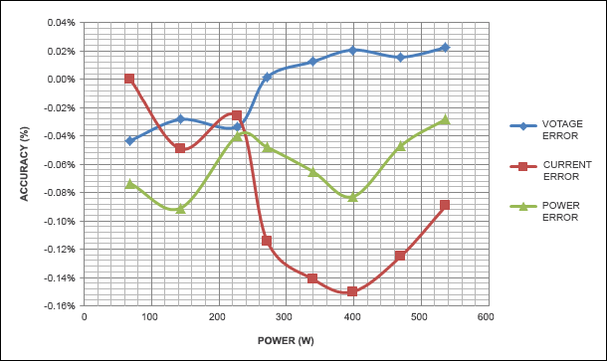  
*Figure 11. Load line at 120VRMS.*

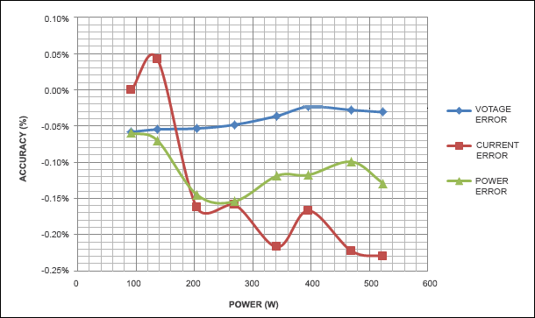  
*Figure 12. Load line at 230VRMS.*

**Conclusion**

Many systems (such as server power supplies) require accurate real-time reporting of

power,

current,

voltage,

and all electrical characteristics of the load.

This reporting is required for proper load management and diagnostics.

In order to achieve high accuracy, an in-system calibration is recommended. As we have seen in this application note, the 78M6610+PSU provides on-chip routines to perform fast in-system calibration. These routines allow the reduction of test and calibration time, thereby reducing costs.